# Acceleration model

## Hypothesis

* Non-deformable tires
* No slip of tires
* No suspensions
* No loss in transmission
* The support and aerodynamic drag are considered
* No transitional regime considered

### Additional information

* The mechanical equation was obtained with a theorem of kinetic energy on the whole vehicle.
* Choice for the coefficient of friction:
  + Constant
  + Value corresponding to 11% slip for 13 inches and 12.5% for 10 inches (maximal friction)
* Engine curve taken from a previous vehicle

## Principal exploitation of the model

Determination of the wheel size

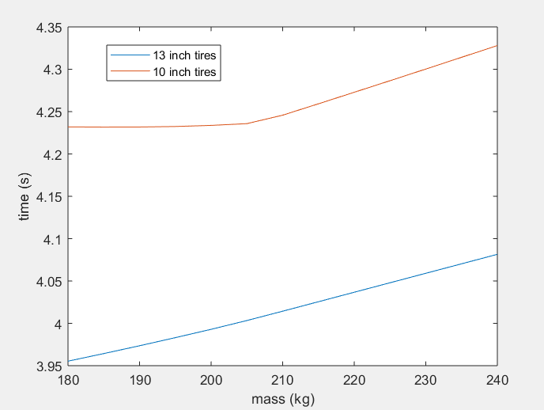

#### Comparison of acceleration event simulation time for 10 inch and 13 inch

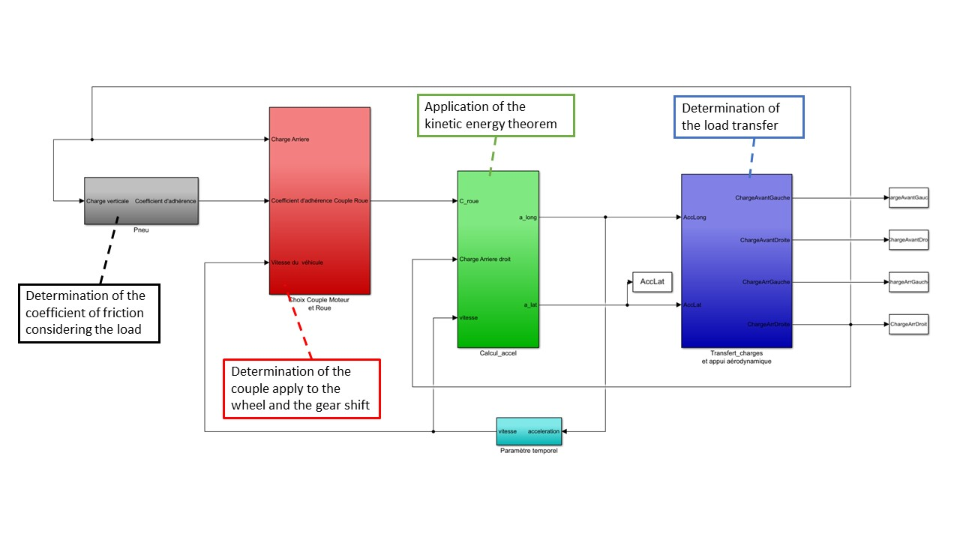

#### Presentation of the simulink model